Dread Abbey
A 2nd-Level Quest for Draw Steel
by Look Out Behind You Studios

“Dread Abbey” is an independent product published under the DRAW STEEL Creator License and is not affiliated with MCDM Productions, LLC. DRAW STEEL © 2024 MCDM Productions, LLC.
Dread Abbey © 2025 Look Out Behind You Studios LLC

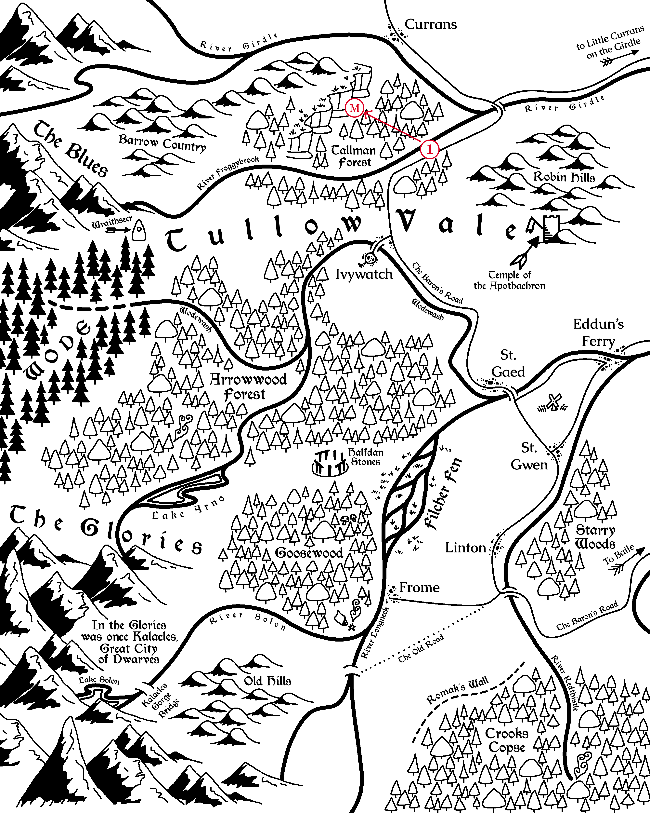
Marked in red are the scenes of MacGraw Hideaway (1: Scene 1, M: Scenes 2 & 3).

Dread Abbey
Dread Abbey is a one-shot set in Vasloria, a woody, humid, and vaguely Europe-like region of Orden. The quest is designed for two to seven 2nd-level heroes. The heroes might all survive, but if a hero dies, their player will have major ways to participate up to the end!

MacGraw Boss, Blarg
The bugbear Blarg has been exiled from his home in Tullow Wode. He seeks to gain power in the way that humans do: wealth and politicks. The goblins he commands are convenient for now, but given another week, he would kill them all himself and take his earnings to the nearest city.

Enter the Victims

